QUANTUM SCATTERING
Computational Project Report
Yifeng CHEN
Student ID: 999016959

Part 1 — Free Gaussian wave packet
The free Gaussian wave model is,
$$ψ(0,x) = {\left(2a/π\right)}^{\frac{1}{4}} \exp\left(−a{\left(x−x_{0}\right)}^{2}\right) \exp\left(i p_{0}\left(x−x_{0}\right)\right)$$
Using m = ℏ = 1, the free-particle time-independent Schrödinger equation is
$$−\left(1/2\right) d^{2}u_{p}(x)/dx^{2} = E u_{p}(x).$$
With E = p²/2, this becomes d²uₚ(x)/dx² + p²uₚ(x) = 0, whose solutions are plane waves exp(±ipx). For the momentum eigenstate with momentum p, the plane-wave form used in the Fourier expansion is
$$u_{p}(x) = \frac{1}{\sqrt{2π}} \exp\left(ipx\right).$$
The initial Gaussian packet can therefore be expanded in these free-particle momentum eigenstates. Its momentum-space amplitude Φ(p) is obtained from the Fourier transform
$$Φ(p) = \frac{1}{\sqrt{2π}} \int{ψ(0,x) \exp\left(−ipx\right) dx}$$
During free propagation, each momentum component keeps the same amplitude Φ(p) and gains the free-particle phase exp(−ip²t/2), giving
$$ψ(t,x) = \frac{1}{\sqrt{2π}} \int{Φ(p) \exp\left(ipx\right) \exp\left(−ip^{2}t/2\right) dp}$$
Figure 3 uses this expression at t = 0, 4, and 8.

1.1 Changing the width
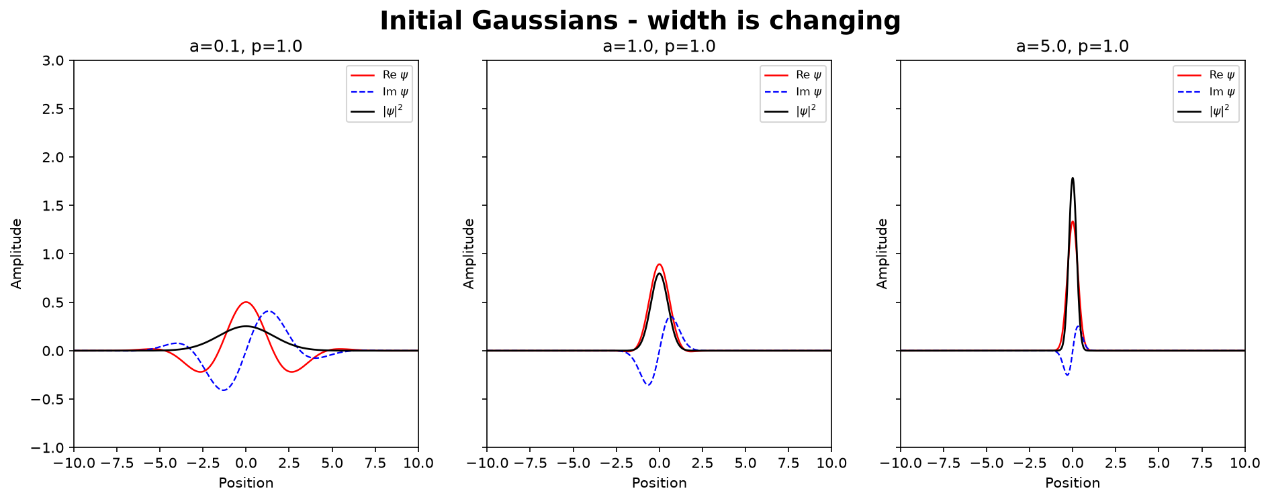
Figure 1. Initial Gaussian states for a = 0.1, 1, and 5 with p₀ = 1.
With p₀ = 1 fixed, increasing a makes the real-space probability distribution narrower because Δx=1/(2√a) at t=0.

1.2 Changing the mean momentum
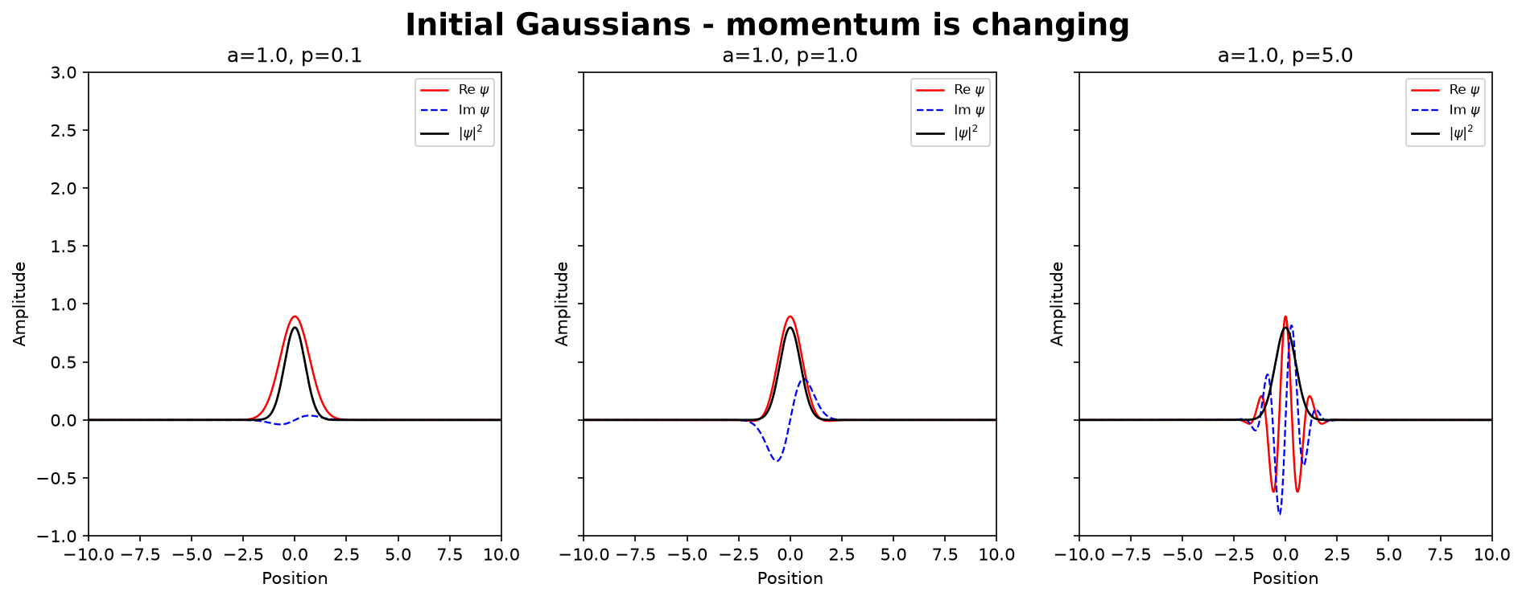
Figure 2. Initial Gaussian states for p₀ = 0.1, 1, and 5 with a = 1.
When a is fixed, a larger p₀ makes the real and imaginary parts oscillate more rapidly inside the same envelope. However, the Gaussian probability distribution, |ψ|², is unchanged when p₀ is varied.

1.3 Free propagation
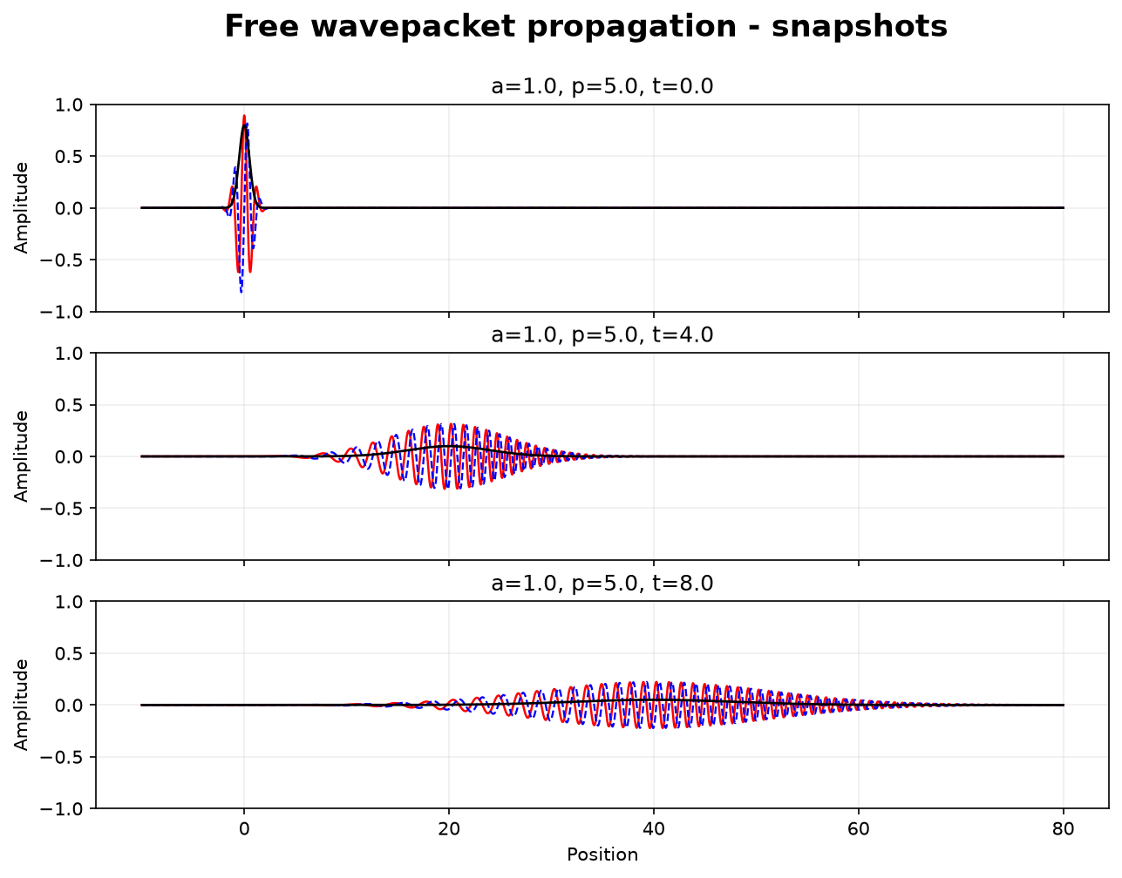
Figure 3. Free propagation for a = 1 and p₀ = 5 at t = 0, 4, and 8.
For t>0, the whole Gaussian wave moves to the right with a center velocity equaling p₀/m. At the same time the packet also spreads, so the Gaussian wave also becomes wider as time increases.

Part 2 — Regularized Dirac delta function
The Dirac delta function is defined through its action on a smooth test function f(p):
$$\int_{−∞}^{+∞}{f(p)δ(p)dp} = f(0)$$
For the numerical calculation, the regularized Dirac delta function used in this project is
$$δ_{L}(p) = \frac{1}{2π} \int_{−L}^{L}{e^{ipx}dx} = \frac{\sin{(Lp)}}{πp}$$
As L → ∞, the regularized function approaches the Dirac delta distribution, so that
$$\lim_{L → ∞} \int_{−∞}^{+∞}{f(p)δ_{L}(p)dp} = f(0)$$
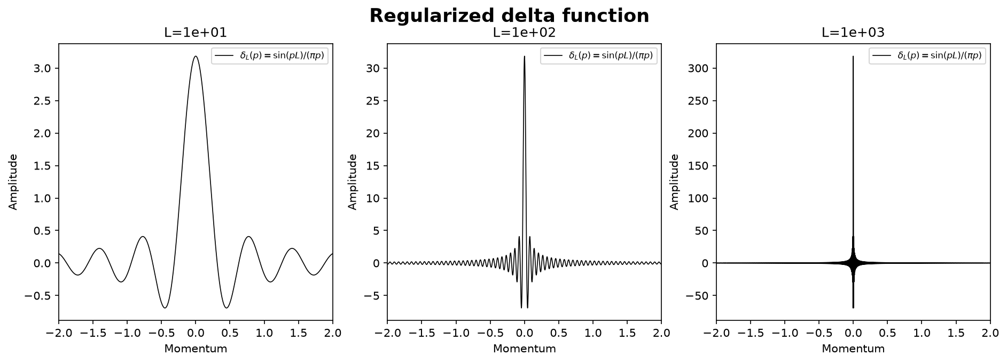
Figure 4. Finite-cutoff delta functions for L = 10, 100, and 1000.
As L increases, the central peak becomes higher and narrower and the side oscillations become more rapid.

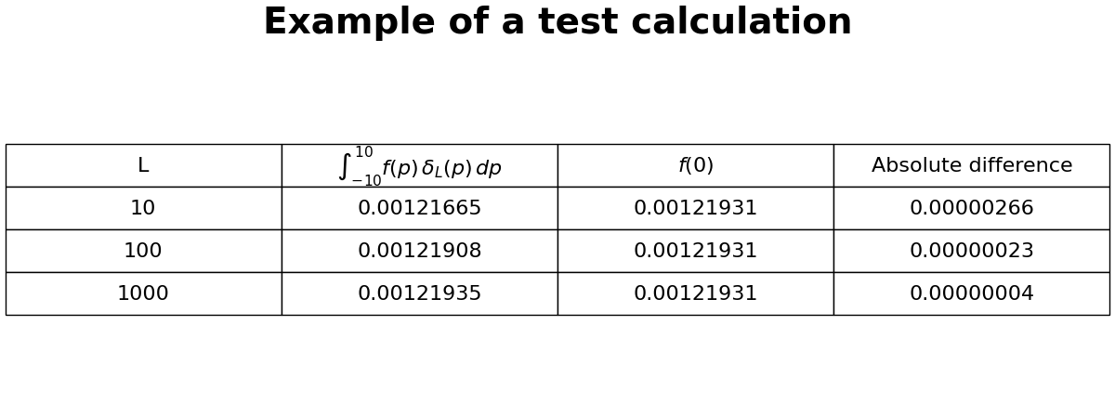
Figure 5. Numerical test of ∫ f(p)δ_L(p) dp on the fixed interval [−10,10].
The target value is f(0) = 0.0012193111. The absolute difference decreases from 2.66×10⁻⁶ at L = 10 to 2.26×10⁻⁷ at L = 100 and 3.70×10⁻⁸ at L = 1000. This confirms the expected delta-function behavior for the chosen smooth test function.

Part 3 — Stationary scattering and resonances
The scattering calculation uses the symmetric double-barrier potential:
$$V(x) = \left(\frac{x^{2}}{2} − 0.8\right) \exp\left(−0.1x^{2}\right),$$
which forms a central well between two barriers.
For each E, the calculation starts on the far right with a single outgoing wave, where k=√(2E) in the chosen units.
$${\overline{ψ}}_{E}(x → +∞) = \exp\left(ikx\right).$$
Using the right-side values from this wave, the recurrence relation
$${\overline{ψ}}_{E}(x_{n−1}) = \left[2 + 2{\left(Δx\right)}^{2}\left(V(x_{n}) − E\right)\right] {\overline{ψ}}_{E}(x_{n}) − {\overline{ψ}}_{E}(x_{n+1}).$$
is applied point by point toward the left. In the left free region, the result is matched to
$${\overline{ψ}}_{E}(x → −∞) = A(E) \exp\left(ikx\right) + B(E) \exp\left(−ikx\right).$$
A(E) is the incoming-wave coefficient and B(E) the reflected-wave coefficient. Dividing by A(E) gives
$$ψ_{E}(x) = \frac{{\overline{ψ}}_{E}(x)}{A(E)},$$
and hence
$$T(E) = \frac{1}{A(E)}, R(E) = \frac{B(E)}{A(E)}.$$
Scanning E gives the transmission probability |T(E)|². Resonances appear as sharp peaks in this curve.
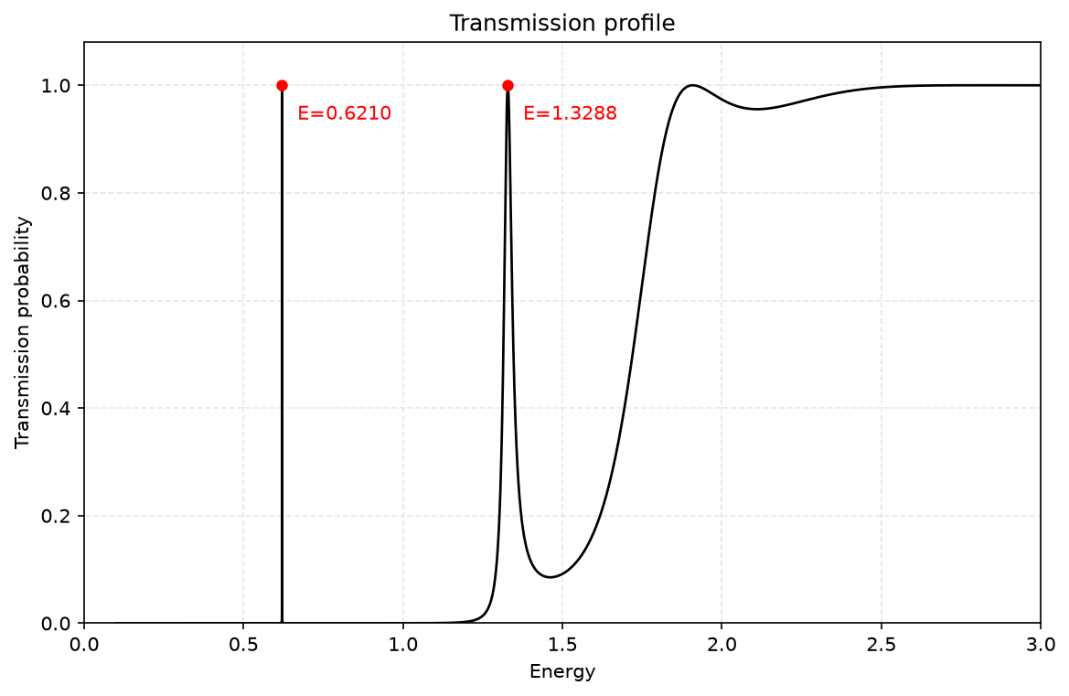
Figure 6. Transmission probability over 0 < E < 3.
The finite-difference maxima occur at E₁ ≈ 0.62097030 and E₂ ≈ 1.32882395. At both resonances, the transmission probability reaches almost one. The first peak is much narrower than the second, while at higher energies the transmission gradually approaches one.

3.1 Resonance peaks
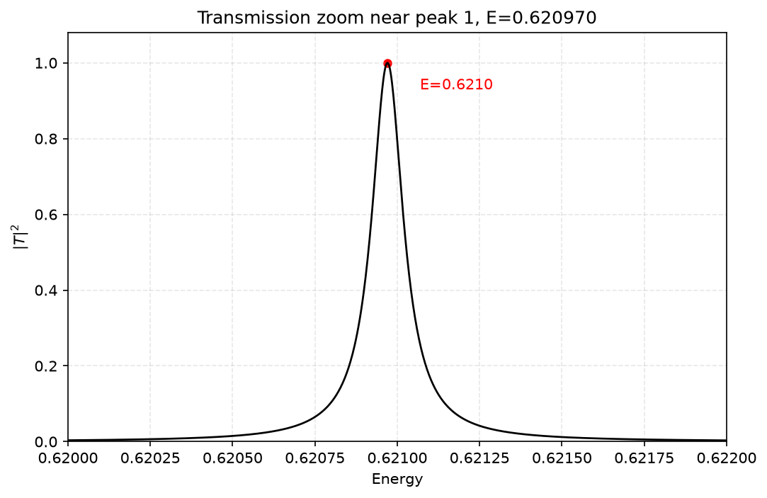
Figure 7. Zoom of the first transmission resonance peak.
A very small change in energy around E₁ ≈ 0.62097030 produces a large change in transmission. This shows that the first resonance is extremely narrow.

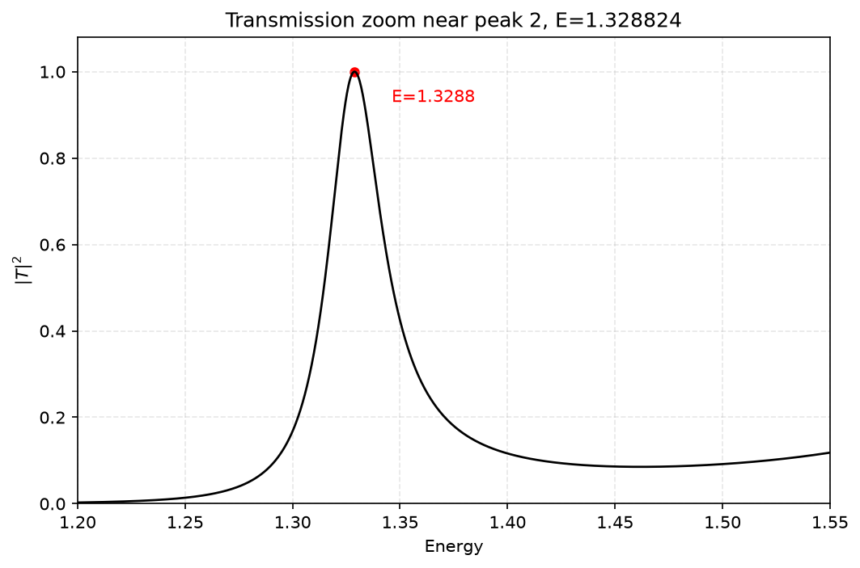
Figure 8. Zoom of the second transmission resonance peak.
The second peak is centered at E₂ ≈ 1.32882395. Compared with the first resonance, the peak is much broader.

3.2 Continuum wave functions around the two resonance peaks
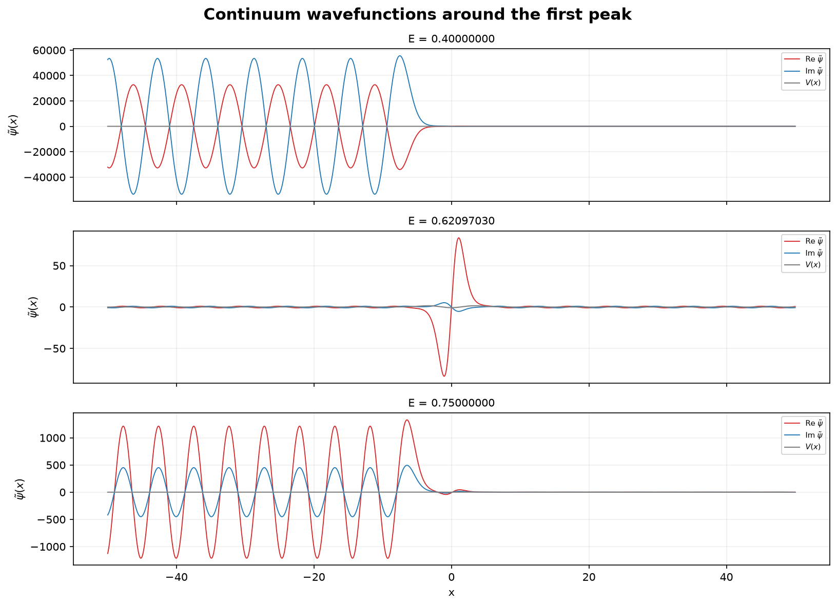
Figure 9. Wave functions around the first resonance peak.
First resonance. For E=0.40 and E=0.75, the wave is mainly reflected because the transmission probability is close to zero. At E≈0.62097030, the transmission rises to nearly one, so the wave passes through the potential almost completely. The resonance is also accompanied by a pronounced oscillation inside the central well.

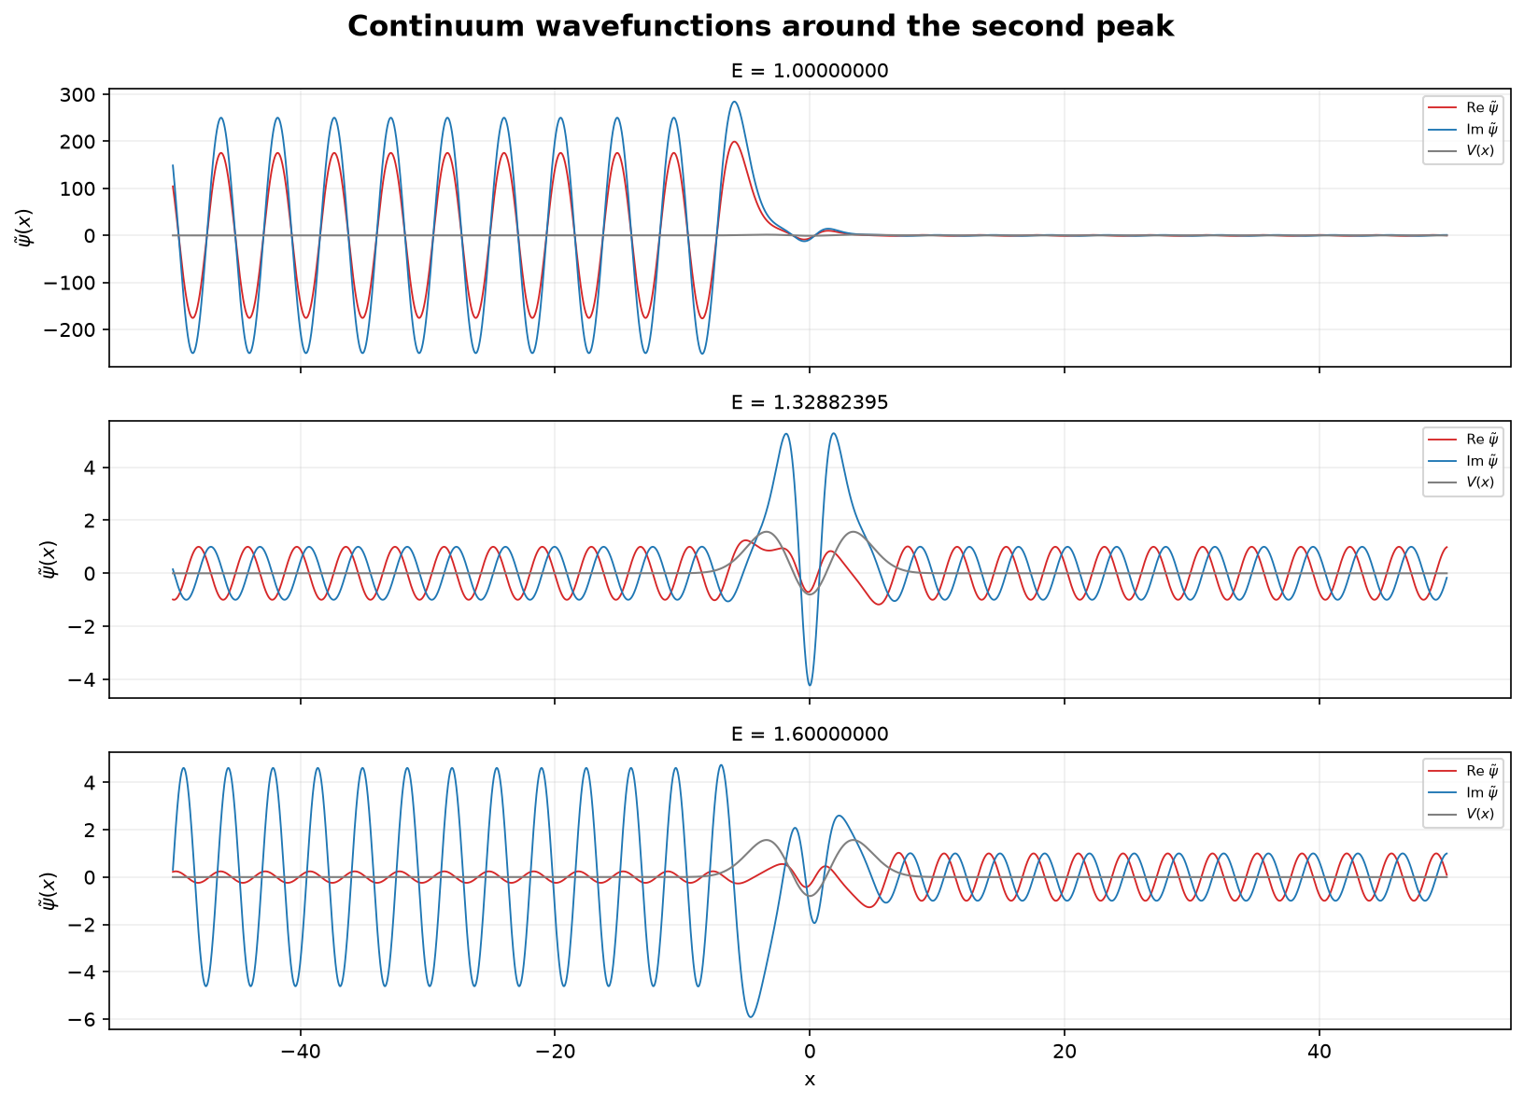
Figure 10. Representative raw continuum states around the second resonance.
Second resonance. At E=1.00 and E=1.60, the transmission is lower and a significant part of the wave is reflected. At E≈1.32882395, |T|²≈1, so the wave is transmitted almost completely through the potential. A pronounced oscillation also appears inside the central well.

Part 4 — Time-dependent scattering wave packets
The time-dependent wavepacket is constructed by adding the stationary scattering states from Part 3 with a Gaussian momentum distribution. Different momentum ranges are then chosen to demonstrate blocked, partially blocked, and pass cases.
$$Ψ(t,x) = \int{Φ(p) ψ_{p}(x) \exp\left(−ip^{2}t/2\right) dp}$$
The incident packet sets the momentum weights through
$$Φ(p) = \frac{1}{\sqrt{2π}} \int{Ψ(0,x) \exp\left(−ipx\right) dx}$$
Each p therefore contributes one Part 3 scattering state with its own phase. A momentum range covering both high- and low-transmission energies produces both transmitted and reflected parts, while a range inside a high-transmission region mainly passes through.
In the figures, a0 is the momentum uncertainty. The figures also show √2 a0, which corresponds to the width parameter of the momentum-space Gaussian amplitude Φ(p).

4.1 Blocked
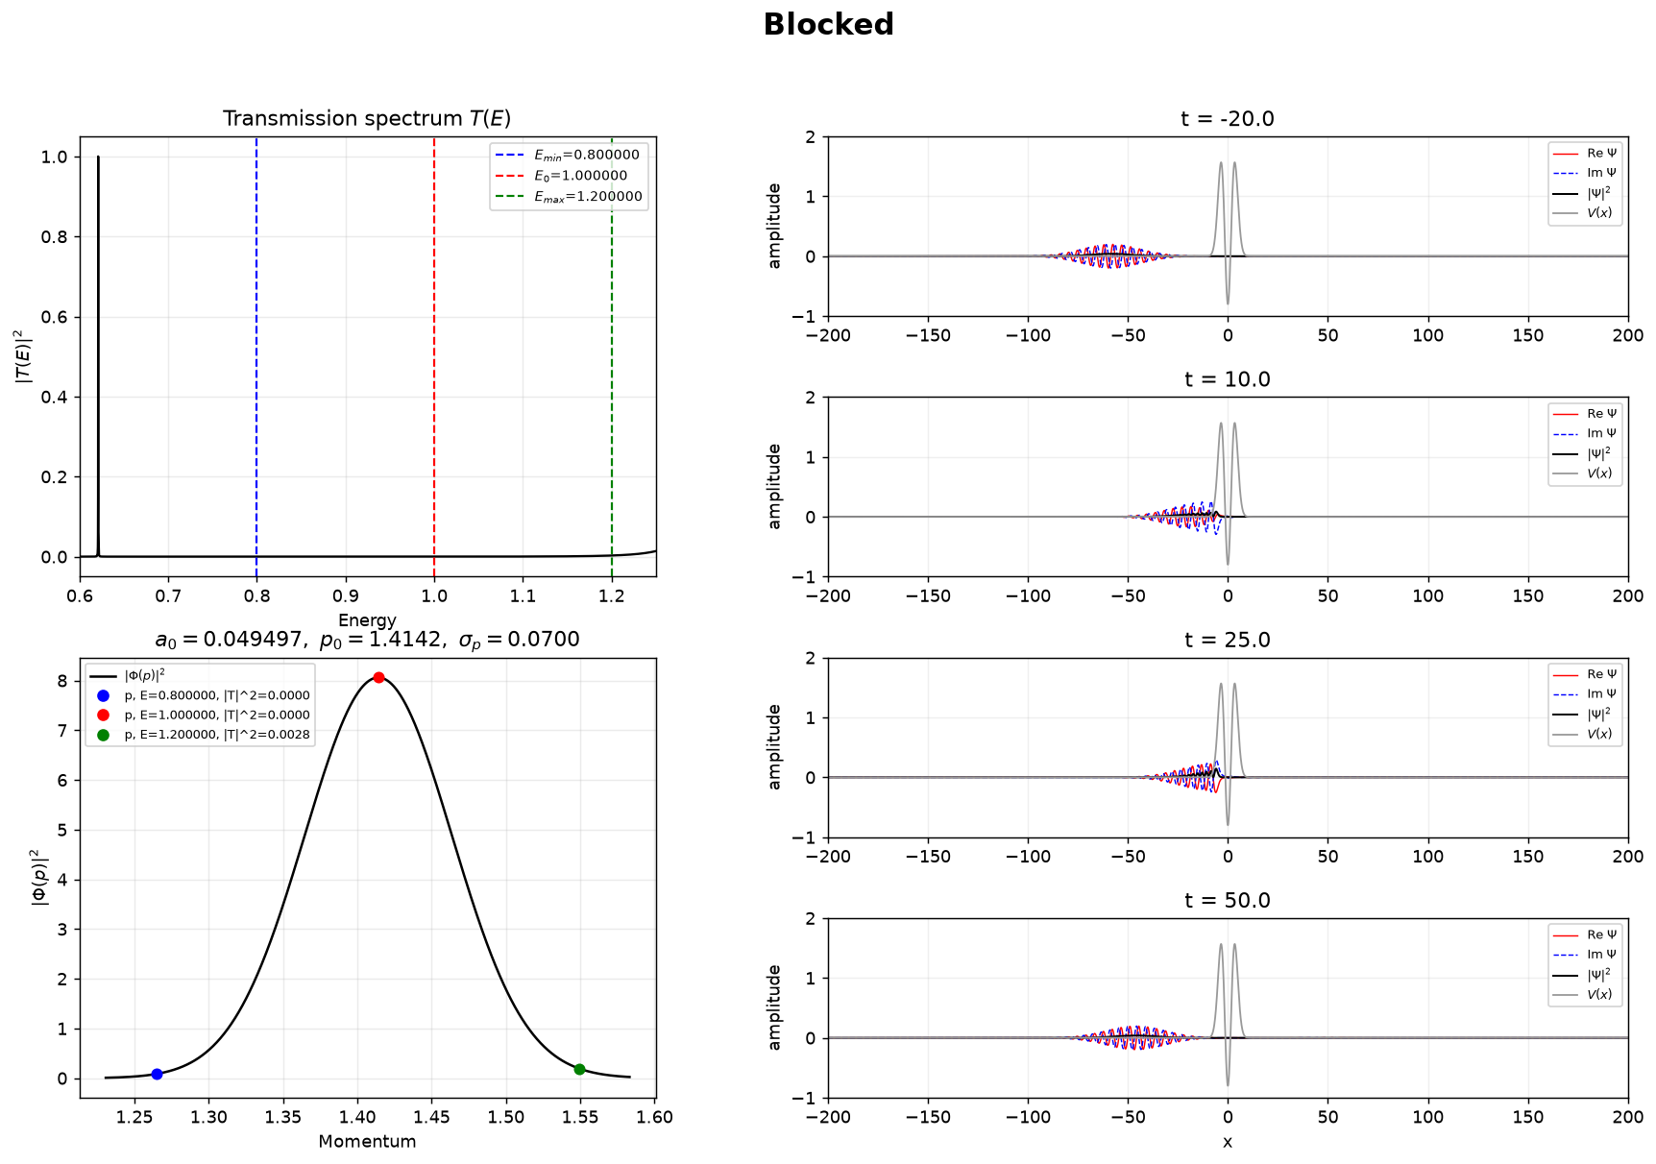
Figure 11. Blocked wave packet: E = 0.8–1.2, centered at E₀ = 1.0.
Almost the whole momentum distribution therefore lies in a low-transmission region. The packet approaches the potential and almost all of the packet is reflected.

4.2 Partially blocked
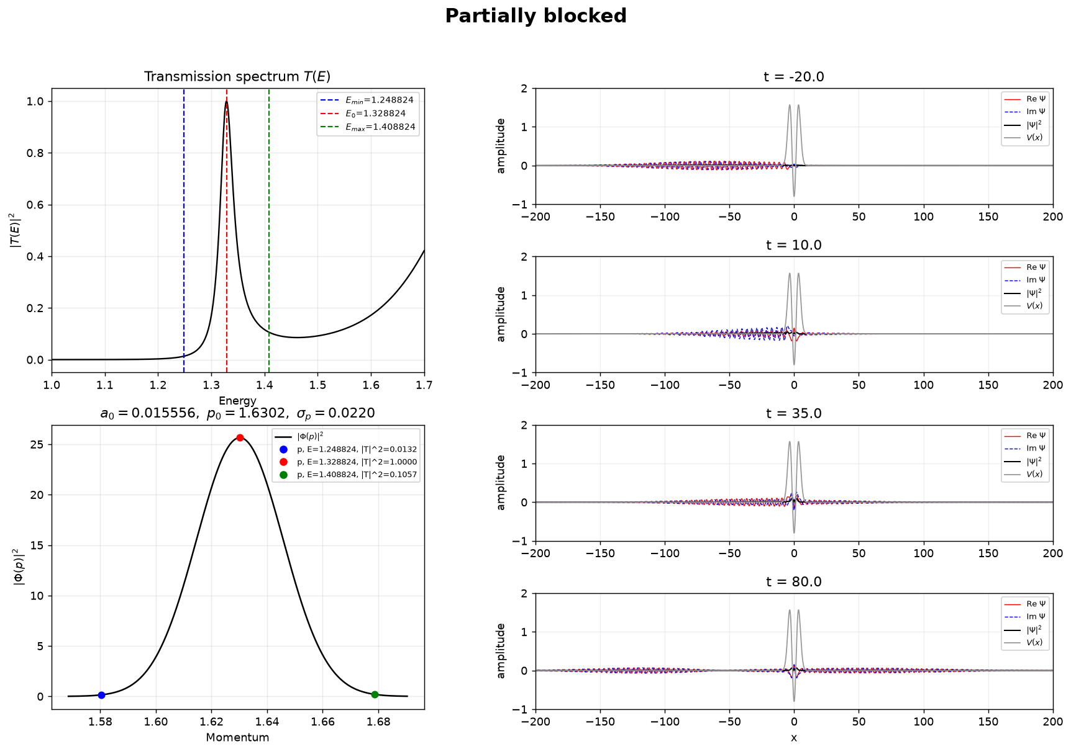
Figure 12. Partially blocked packet centered at the Part 3 second peak, E₀ = 1.32882395.
The center energy is exactly the Part 3 finite-difference value E₂=1.32882395, where the transmission is almost one. The edge markers have transmission probabilities of about 0.013 and 0.106. Because this wider packet contains both high- and low-transmission components, it separates into transmitted and reflected parts.

4.3 Pass
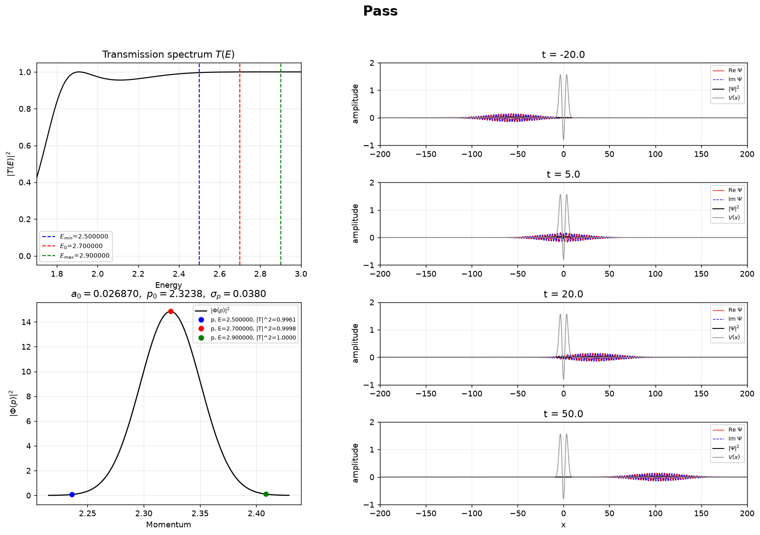
Figure 13. High-energy packet: E = 2.5–2.9, centered at E₀ = 2.7.
Across this interval the transmission probabilities are all almost 1. The wave packet therefore passes through the potential almost completely, with nearly no reflected part.

4.4 Narrow packet around the first resonance
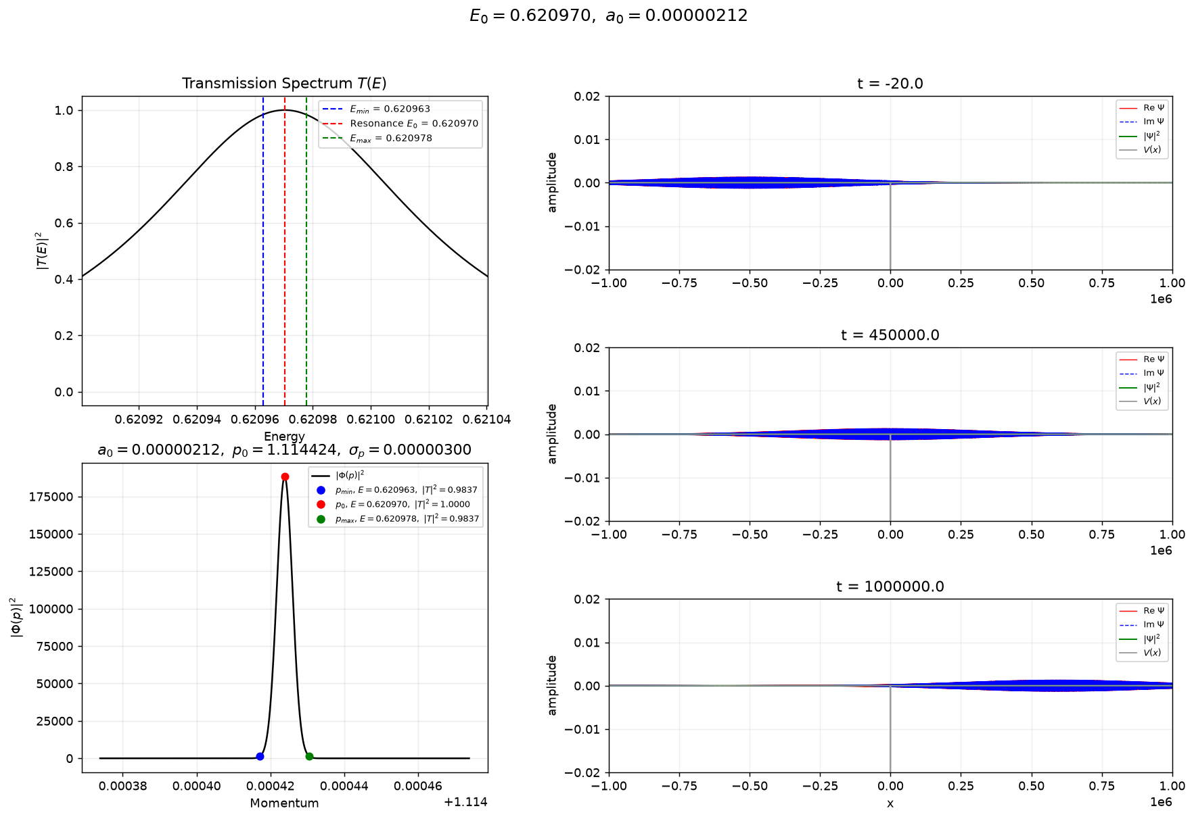
Figure 14. Narrow packet centered at the Part 3 first peak, E₀ = 0.62097030.
The calculation is centered at the first resonance, E₀ = 0.62097030, and uses an extremely small momentum width because this resonance is very narrow. Nearly all spectral components have transmission close to one, so most of the wave passes through the potential. The very small momentum width also makes the packet very broad in real space.

4.5 Narrow packet around the second resonance
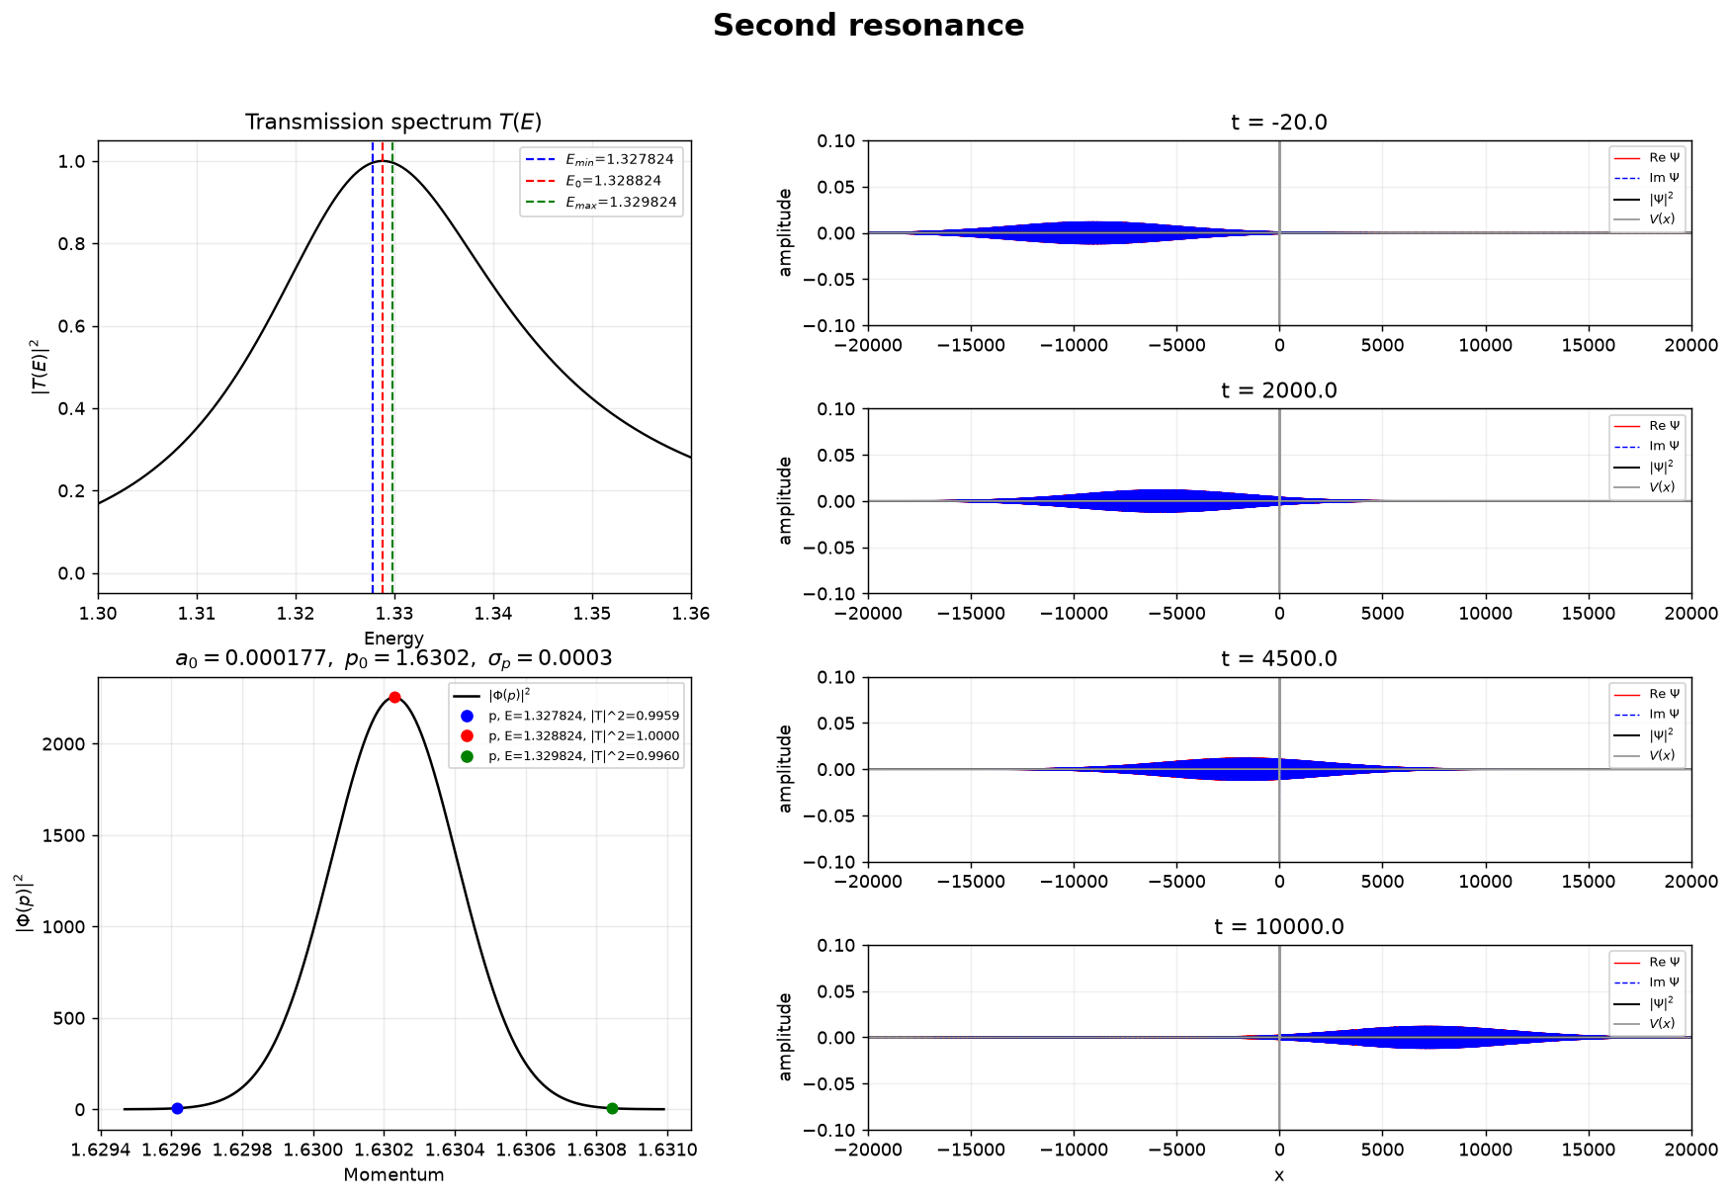
Figure 15. Narrow packet centered at the Part 3 second peak, E₀ = 1.32882395.
This calculation is centered on the same finite-difference value E₂=1.32882395 and uses a very narrow energy window. Nearly all spectral components have transmission close to one, and most of the wave passes through the potential. The very small momentum width also makes the packet very broad in real space.

Part 5 — Box-basis matrix calculation
The stationary Schrödinger equation is also solved in a finite box by expanding the wave function in a sine basis. The basis function used in the calculation is
$$φ_{j}(x) = \sqrt{\frac{2}{L}} sin\left[jπ\left(x + L/2\right)/L\right], j = 1, 2, …, J.$$
The wave function is written as
$$ψ_{n}(x) = \sum_{j = 1}^{J}{c_{j}^{(n)} φ_{j}(x)}.$$
For m=ℏ=1, the Hamiltonian is
$$\hat{H} = −\frac{1}{2} \frac{d^{2}}{dx^{2}} + V(x).$$
In the sine basis, its matrix elements are
$$H_{ij} = ⟨φ_{i}|\hat{H}|φ_{j}⟩ = T_{ij} + V_{ij}.$$
where
$$T_{ij} = \frac{j^{2}π^{2} δ_{ij}}{2L^{2}},$$
$$V_{ij} = \int_{\frac{−L}{2}}^{\frac{L}{2}}{φ_{i}(x)V(x)φ_{j}(x) dx}.$$
The kinetic-energy term is diagonal because the sine basis functions are eigenfunctions of the particle-in-a-box kinetic operator. The potential term can couple different basis functions.
After the Hamiltonian matrix is constructed, the eigenvalue equation
$$H c^{(n)} = E_{n} c^{(n)}.$$
is solved numerically to obtain the energies and eigenvectors. The eigenvector c⁽ⁿ⁾ gives the coefficients used to reconstruct ψₙ(x). Here J is the number of basis functions, L is the length of the box, and N is the number of x points. The harmonic oscillator is first used to test the method, and then the same calculation is applied to the short-range potential from Part 3.

5.1 Harmonic-oscillator validation
The harmonic oscillator V(x)=x²/2−0.8 is first used to test the method.
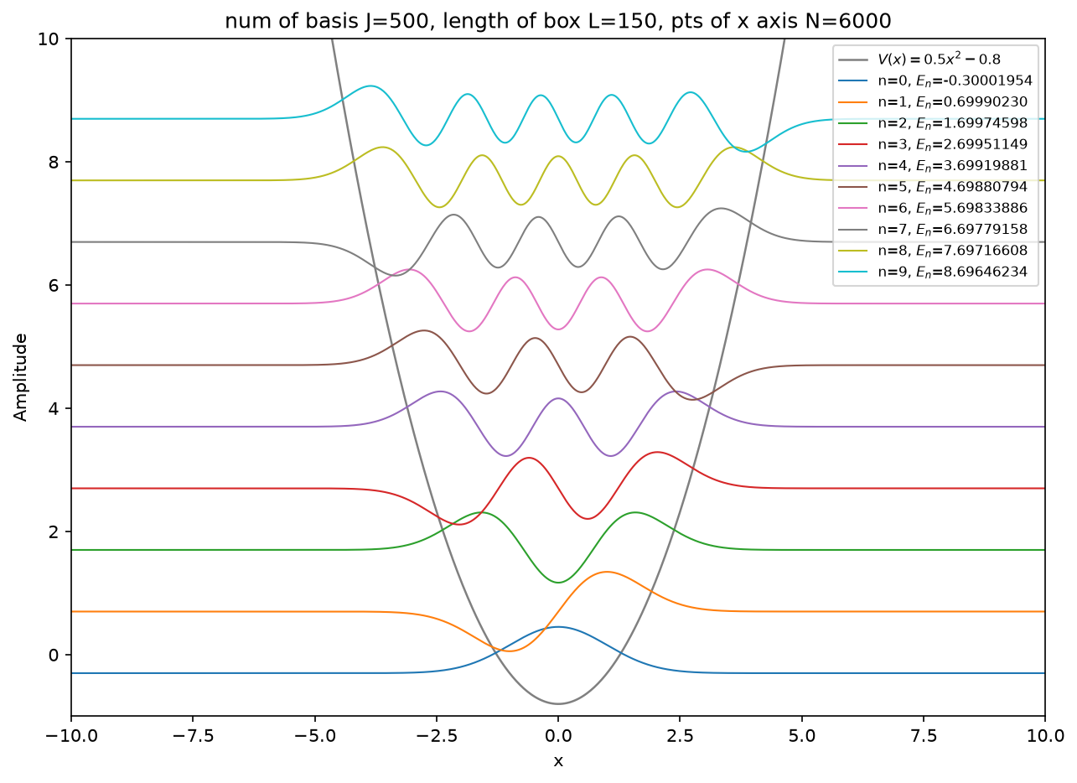
Figure 16. First ten harmonic-oscillator eigenstates obtained with the sine-box basis.
The first ten numerical energies agree with the exact values Eₙ=n−0.3, from −0.3 to 8.7. This shows that the box-basis matrix calculation gives the expected spectrum.

5.2 First 11 short-range eigenstates
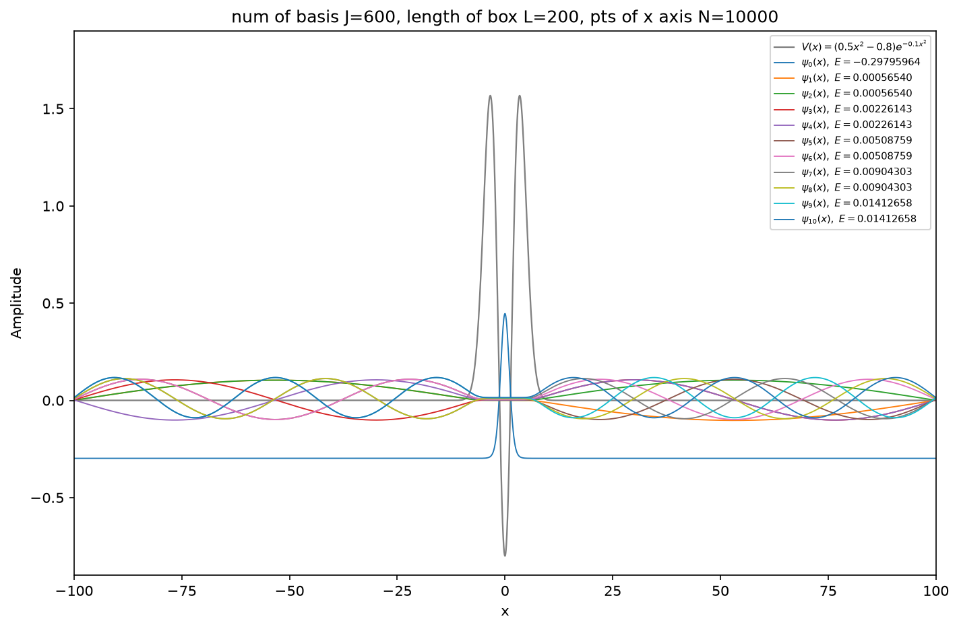
Figure 17. First 11 eigenstates of the short-range potential shown together.
The lowest energy is E₀≈−0.29795964, and this wave function is localized around the central well. The other ten states have small positive energies and extend over the finite box. Therefore, the lowest state is a bound state, while the positive-energy states are discretized continuum states.
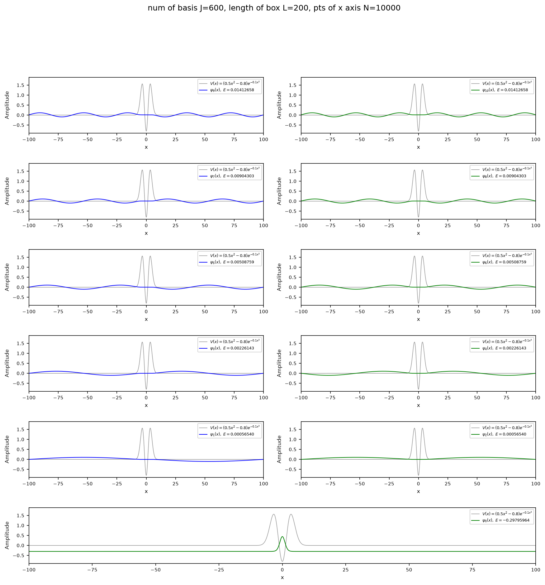
Figure 18. First 11 eigenstates of the short-range potential shown separately.
The separate panels show the shapes of the same 11 states more clearly. As the energy increases, the wave functions have more oscillations over the box, while the bound state remains localized near x=0.

5.3 All box states
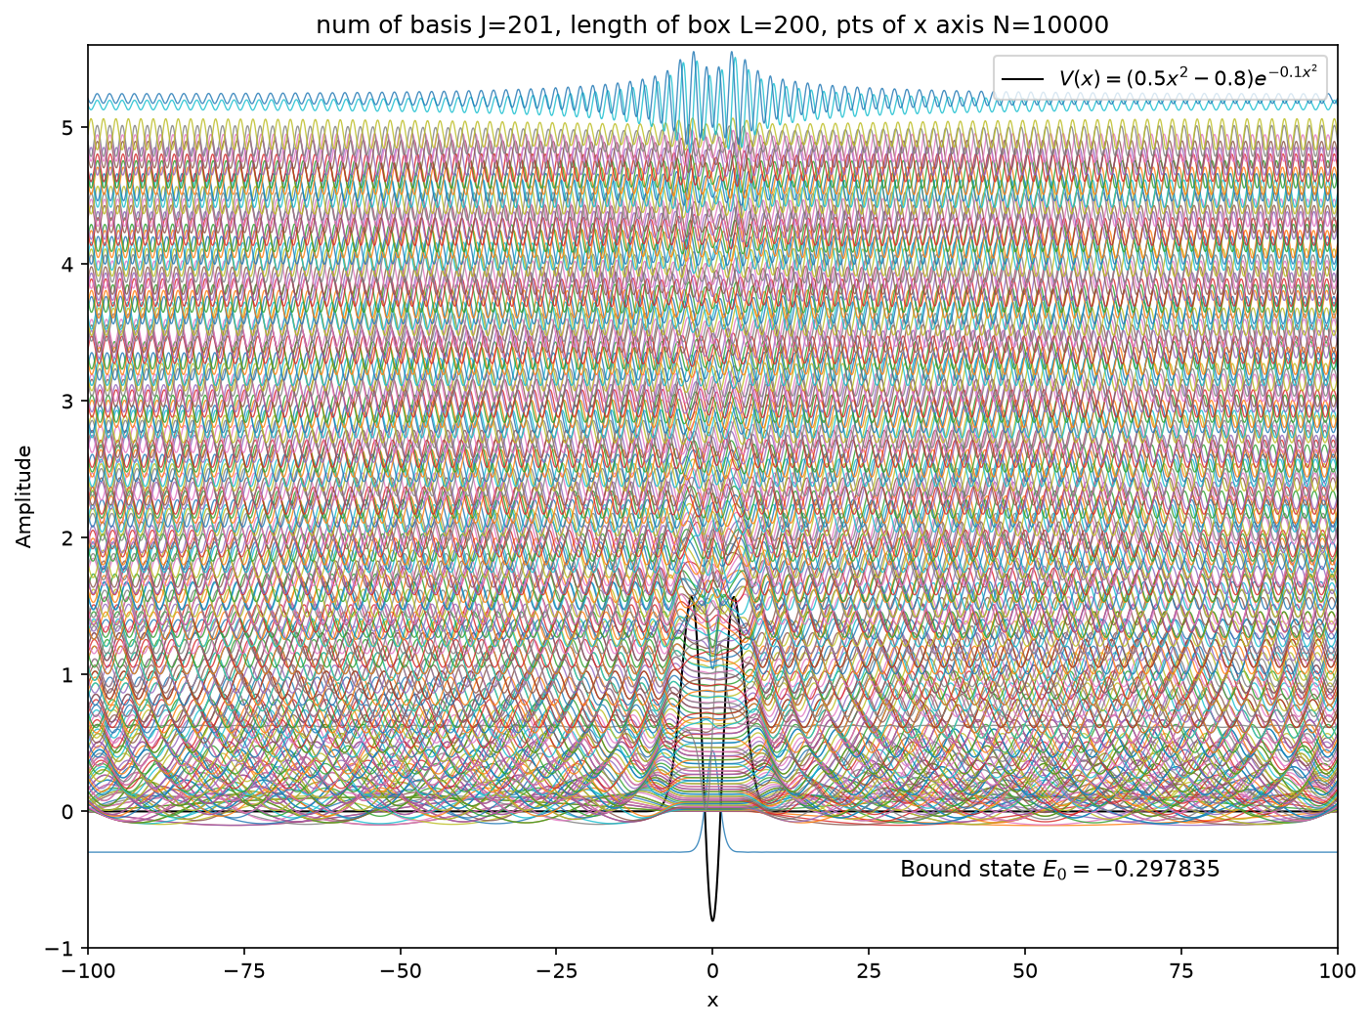
Figure 19. All 201 box eigenstates of the short-range potential.
Only the lowest state has negative energy. The many positive-energy states form a dense set because the finite box changes the scattering continuum into discrete box states. The negative-energy state is separated from them and is the only bound state.

5.4 Bound state and box states near the resonances
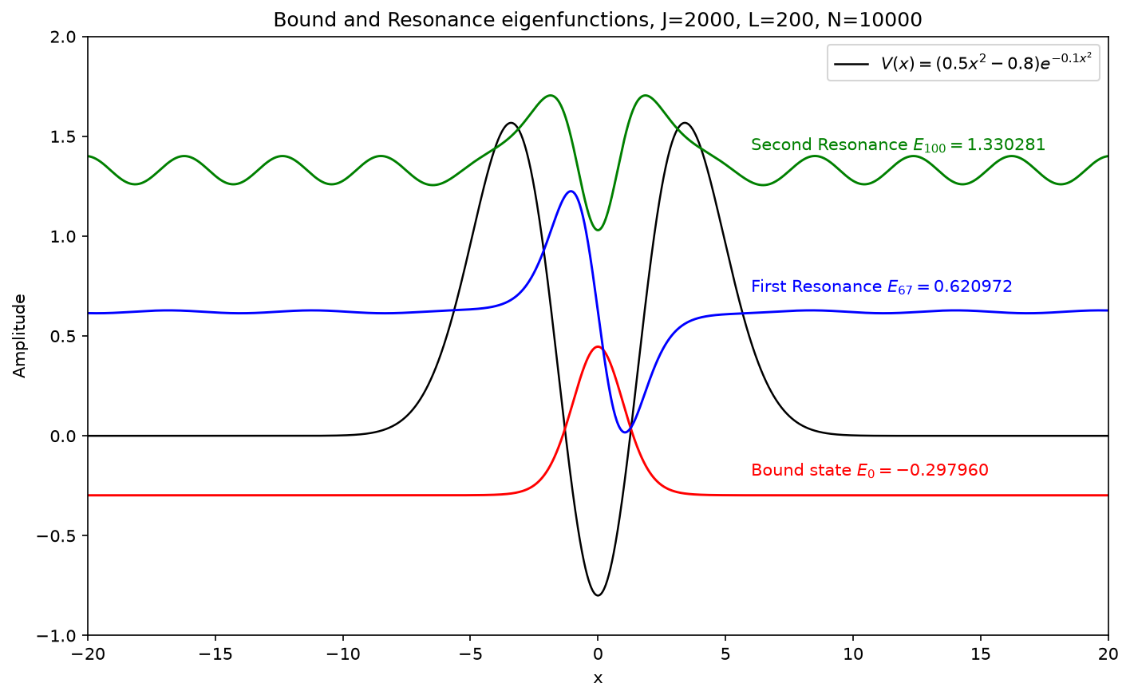
Figure 20. Bound state and two positive-energy box states near the Part 3 resonance energies.
The selected box states are n=0, 67, and 100, with energies E0 ≈−0.29795964, E₁≈0.62097222, and E₂≈1.33028105. The two positive-energy values are close to the Part 3 resonances E₁≈0.62097030 and E₂≈1.32882395. From the wave functions, the state at E₁≈0.62097222 is mainly concentrated near the center, while the E₂≈1.33028105 state spreads farther across the box.
The two positive-energy states are not true bound states because their wave functions still extend outside the barriers. Their exact energies also change when the box length is changed.

Part 6 — Resonance poles from complex scaling
Part 5 gives a real matrix spectrum inside a finite box. In this part, the coordinate in that matrix is continued to x exp(iθ), so the Hamiltonian is no longer Hermitian:
$$H_{θ} = \exp\left(−2iθ\right) T + V\left[x \exp\left(iθ\right)\right] = −\frac{1}{2} \exp\left(−2iθ\right) \frac{d^{2}}{dx^{2}} + V\left[x \exp\left(iθ\right)\right].$$
For each θ, the modified matrix is diagonalized with the same sine basis,
$$H_{θ} c^{(n)} = E_{n}(θ)c^{(n)}.$$
The box calculation uses (J,L,N)=(2000,200,10000). Six rotations are evaluated from θ=0 to 0.25 in steps of 0.05. Comparing the resulting spectra separates the moving box-continuum points from the nearly stationary resonance poles.
For a resonance pole,
$$E_{n} = E_{res,n} − iΓ_{n}/2, Γ_{n} = −2 \text{I}\text{m}(E_{n}).$$
Eres,n fixes the resonance position, whereas Γₙ gives the peak width. The corresponding single-pole transmission curve is
$${\left|T(E)\right|}^{2} ≈ {\left(Γ_{n}/2\right)}^{2} / \left[{\left(E − E_{res,n}\right)}^{2} + {\left(Γ_{n}/2\right)}^{2}\right].$$
The complex eigenvalue therefore supplies both quantities that were only seen as a peak in Part 3. The same coordinate rotation is also applied to the resonance wave function, allowing the unscaled and scaled tails to be compared.

6.1 Rotated continuum and stationary poles
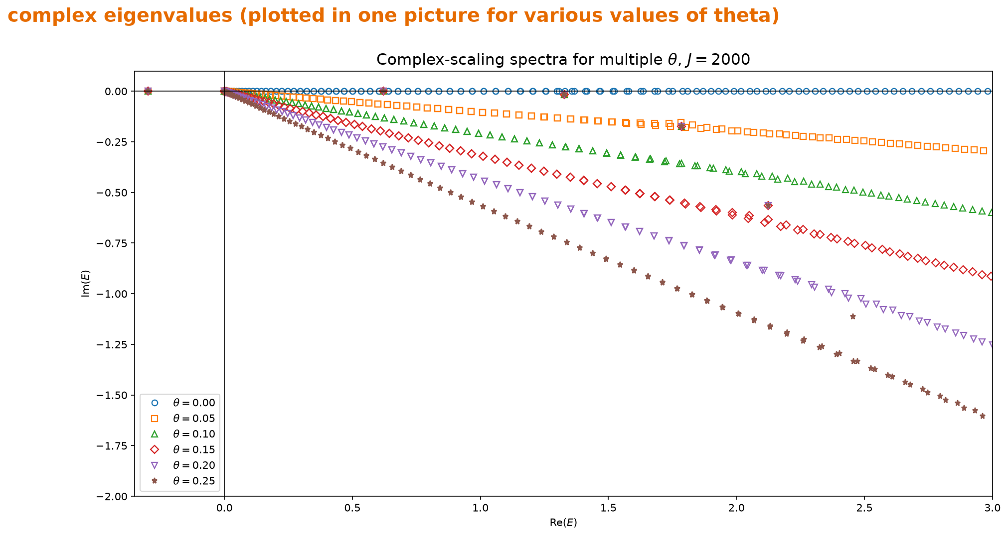
Figure 21. The six complex spectra superposed in one panel.
When θ=0, the box states lie along the real axis. For θ>0 they move onto sloping branches in the lower half-plane. The two isolated points near 0.620971−0.000058i and 1.327197−0.015447i do not follow these branches and are taken as the first two resonance poles.

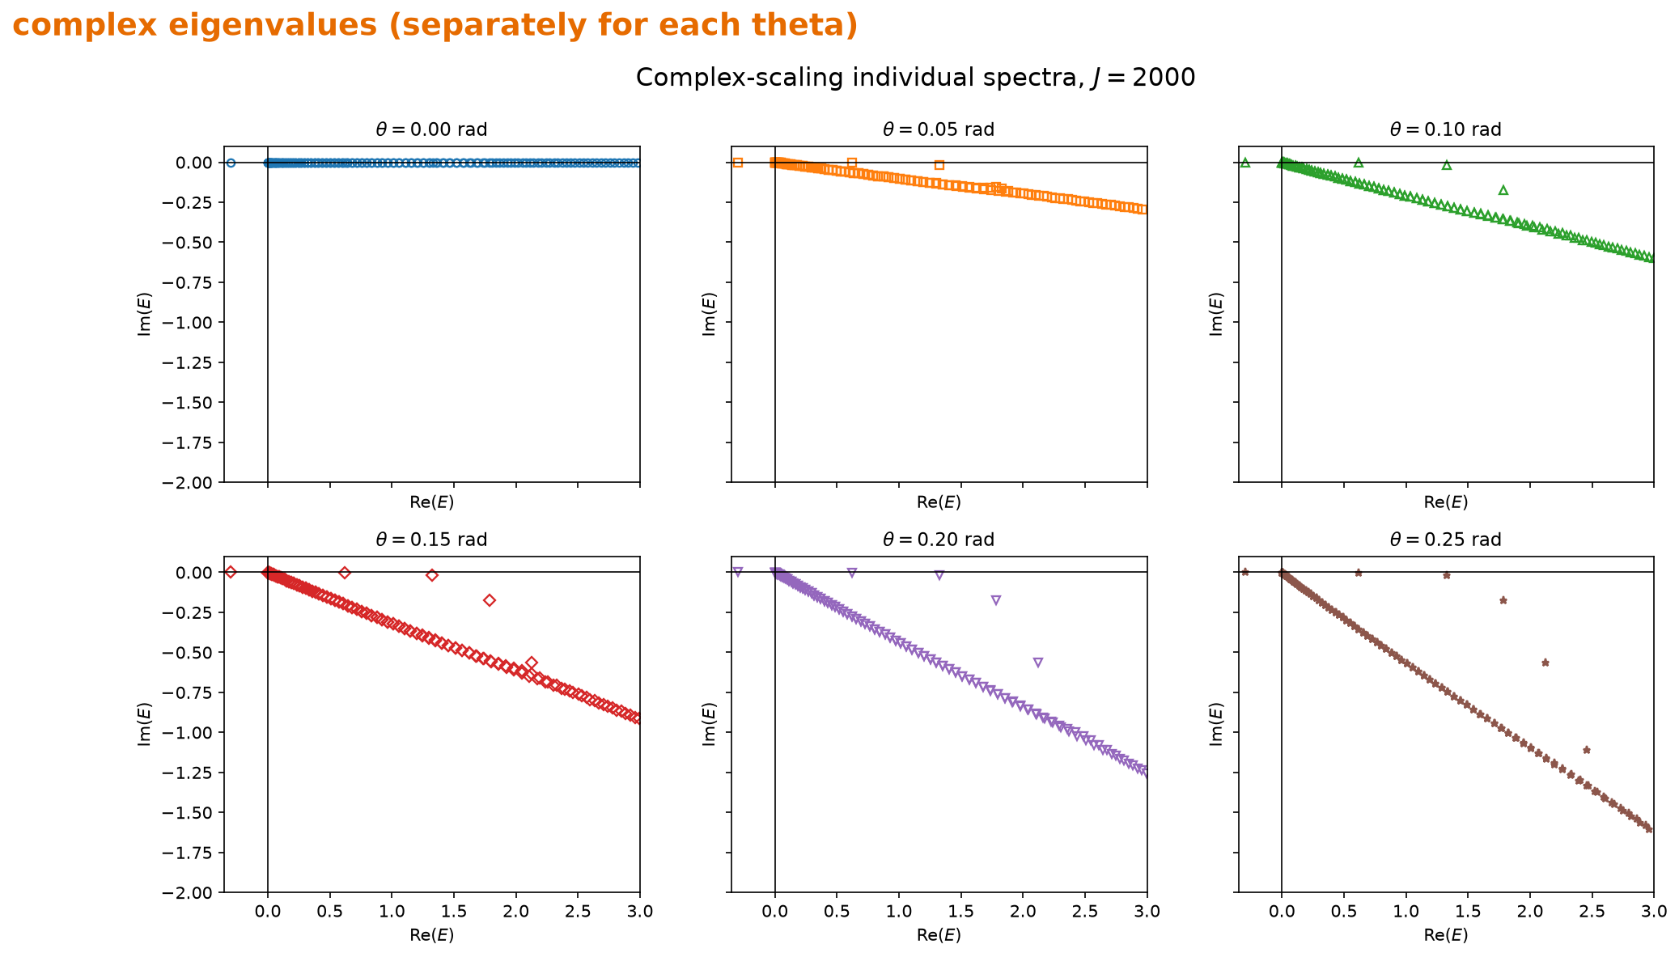
Figure 22. Separate complex-energy panels for the six scaling angles.
The widths follow directly from the imaginary parts: Γ₁≈0.000116 and Γ₂≈0.030894. This large difference matches the line shapes in Part 3: the first peak is extremely sharp, while the second covers a much wider energy interval.

6.2 Transmission curves reconstructed from the poles
The poles above are inserted into the Breit-Wigner formula and plotted together with the finite-difference transmission from Part 3.
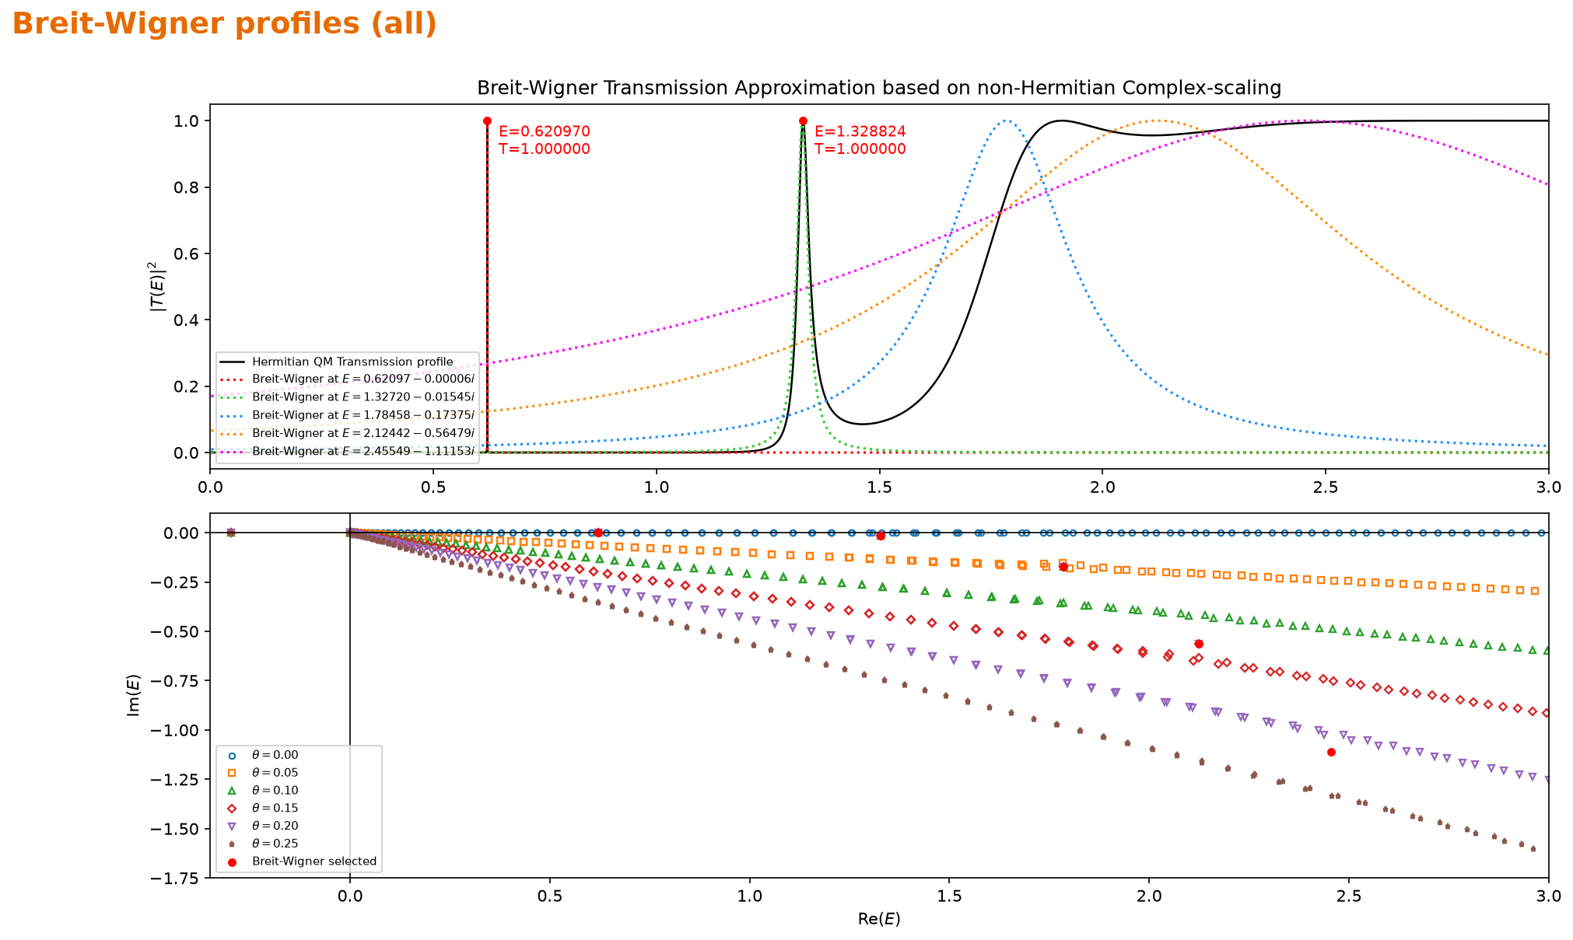
Figure 23. Part 3 transmission curve together with the Breit-Wigner curves generated from the complex poles.
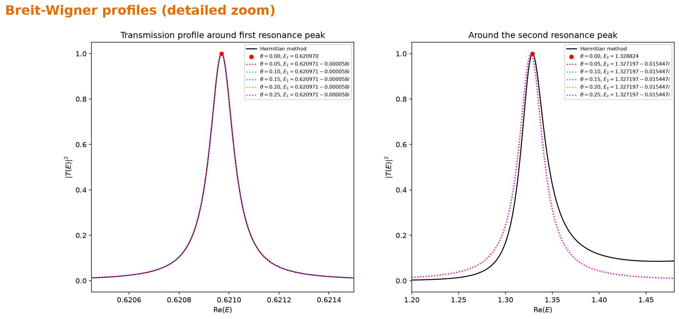
Figure 24. Enlarged views of the two low-energy resonances.
For the first pole, the two curves are almost indistinguishable near the peak. The second pole also places the resonance in the same energy region and gives the expected broader shape, but a single Breit-Wigner term does not reproduce the full background on both sides of the peak.

6.3 What the rotation does to the wave function
For the wave-function test, the pole at E≈1.327197−0.015447i is used. Without complex scaling, the outgoing Siegert solution increases as |x| becomes large. Evaluating the solution at x exp(iθ) with θ=0.1 changes the tails into decay.
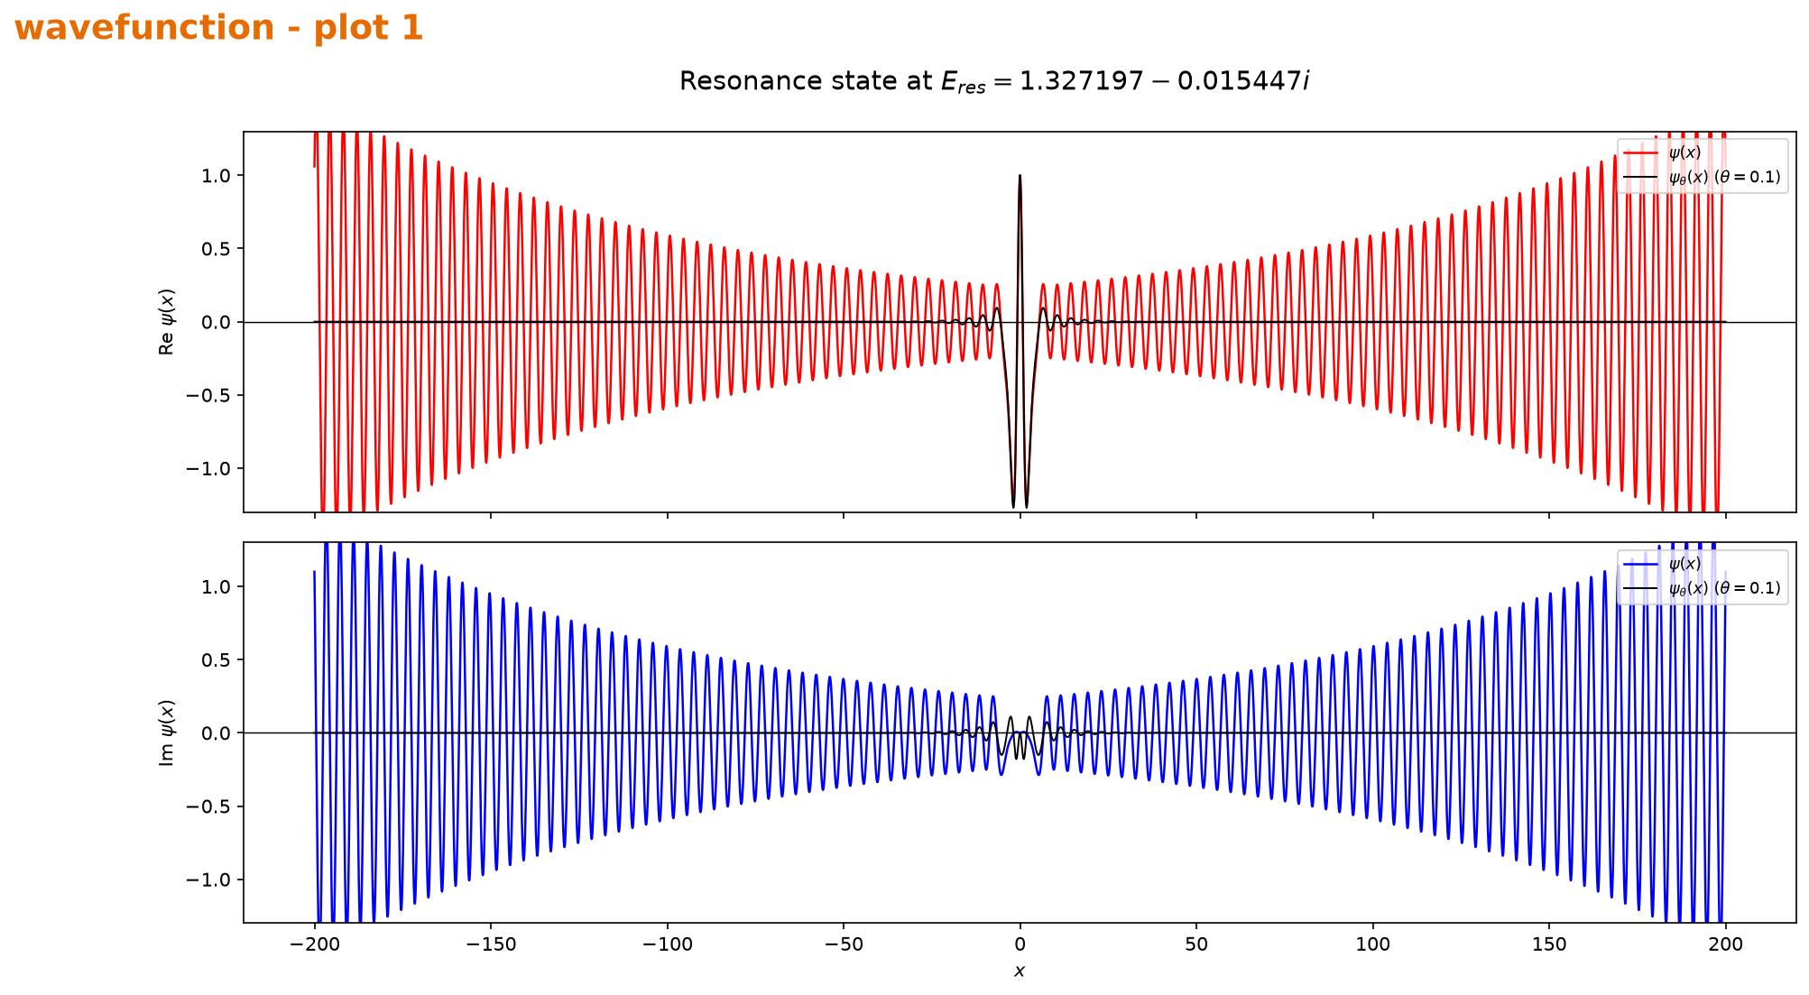
Figure 25. Real and imaginary parts of the second-resonance state on −200≤x≤200.
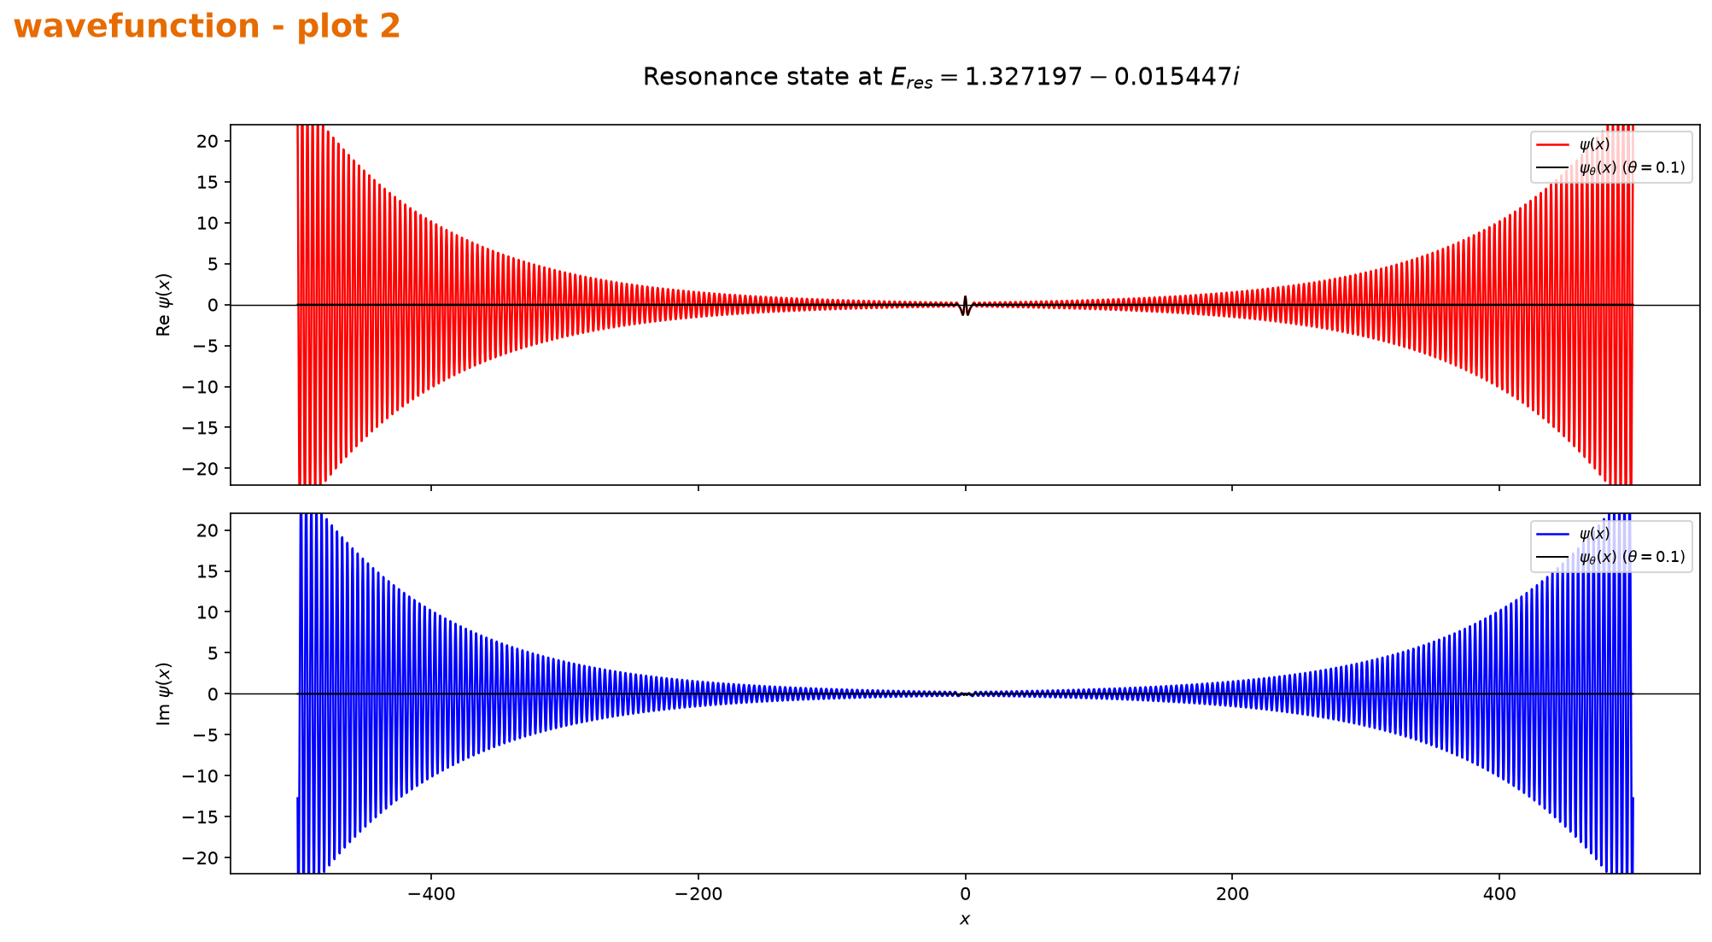
Figure 26. The calculation extended to the interval −500≤x≤500.
On the wider axis, the colored unscaled oscillations grow steadily, whereas the black scaled curve stays concentrated near the interaction region. This is the practical reason the scaled resonance can be handled with a finite basis.

6.4 Check against the Part 3 peak positions
Part 3 locates maxima on the real-energy transmission curve, while Part 6 locates poles of the non-Hermitian matrix. The first pole, 0.620971−0.000058i, lies almost directly below the first Part 3 maximum at 0.62097030. For the second resonance, Re(E)=1.327197 is slightly lower than the Part 3 maximum 1.32882395, but both calculations point to the same energy region. Complex scaling additionally provides the two widths through the imaginary parts.

